**NATIONAL UNIVERSITY OF SCIENCES AND TECHNOLOGY**

**Fundamentals of Programming**

**LAB TASK (MANUAL 8)**

***Hunzala Asaad Qureshi***

**474644**

**Task 1:**

**TASK 2**

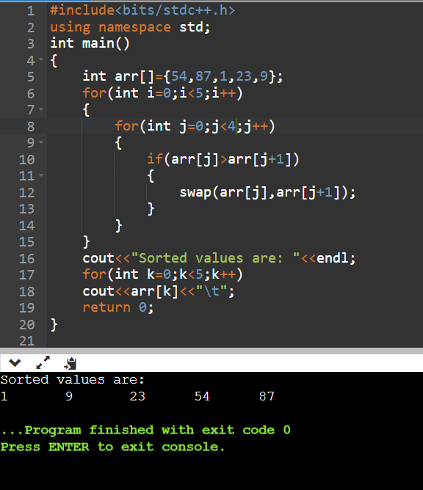

**Task 3**

